Every Day Design by People (or People Designing Spaces): Insights from (or into) ….(mention the situation, the activity and place, including the country)

Name
Address
Email:
Received | Accepted | Published
.2026 | .2026

Abstract
Write your abstract here to be within the first page. It should be comprised of three paragraphs as follows.
Introduction to the situation in which people appear to be doing things where by spaces and places are either created anew or are transformed from already existing. End this paragraph with a statement about which specific aspect is investigated or explored through this paper.
Second paragraph must briefly explain the research methods employed to generate data. Mention the paradigm first: quantitative or qualitative and then, the data gathering techniques such as observations, interviews etc. Present a reasonable depth of details.
The third paragraph must present what the conclusions are particularly the kind of knowledge revealed through the study of this activity of people’s processes. This should not say things like, ‘highlights,’ or ‘emphasizes’ etc. It should be conclusions derived based on data, even if they are not generalizable.

Keywords: please provide 5-6b key words that identify what the research deals with.

Introduction
Under this sub title, introduce the situation of people engaging in activities, that appear to show the making or transformation of spaces and places. Present its background and what prompted this investigation: uniqueness, cultural relevance, new insights etc. Briefly say if similar a similar situation has been explored previously in this location or elsewhere, and if there is any significant research or not. End the introduction with the aim and objectives. Aims and objectives must be stated with ‘to.’ Be brief, do not talk about theory, or previous research or methodology. Please note that aims are noble, long-term, almost-impossible-to-fully achieve intentions, while objectives are mundane, short-term, intentions that must be achieved in this paper itself. Terms such as ‘explore, examine, contribute’ can be used to phrase the aims, but objectives must use terms such as ‘identify,’ ‘produce,’ or establish etc.

Theoretical Framework
Present the key ideas involved in this investigation: facets related to the situation, where ‘design’ appears to manifest, such as culture, every-day knowledge, traditions, rituals etc. and how they may acquire or reveal knowledge. First define the concepts. Afterwards, present what theoretical ideas or theories presented by the theoreticians which are employed in this research to examine this situation and the phenomenon. Produce preferably a graphical representation of the ‘theoretical framework,’ that outline the relations among the theoretical ideas. This should be written using the theoreticians’ voices by using statement such as ‘according to Rapoport (1969)’ or as ‘Olver (1987 points out’ etc.

Review of Literature
Critically review previous research if any, that has examined similar situations or phenomenon and what kind of knowledge they have produced: highlight the agreements and disagreements among the research. Demonstrate the status of current knowledge. Show where the gaps of that knowledge exist

Research Methods
First declare the research paradigm such as qualitative or quantitative methodology and then explain the data gathering techniques or research methods employed. List them first and explain each one separately providing sufficient details to understand how the data gathering has been carried out. Be brief but also mention all the techniques and say how they were implemented. Must be detailed enough so that another researcher can repeat the research.

Case Studies:
This obviously employs case studies as a method. Therefore, introduce the case study or studies here. Be brief, but provide location plans and general details. Provide images of the activities taking place only as an introduction.

Findings
Present data from each of the techniques mentioned under ‘research methodology.’ Then analyze them and show the patterns of the existence of the data. This may involve quotations (if interviews were conducted), graphs or charts if quantitative data was generated. Otherwise, tables and other forms summarizing the patterns must be resented here to show the meanings that cab be derived in qualitative data. Maps, sketches, photographs etc could be presented as data and evidence. Following is an example of a Figure and a table. Please note that table titles are on top and Figure titles are at the bottom. In any case, provide a reference to the source of the table or the figure.

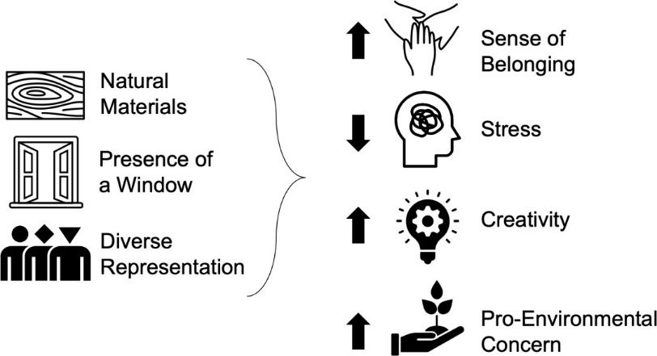
Fig 1: Conceptual diagram highlighting hypothesized relationships between independent
and dependent variables
Source: Agustin, 2022

Table 1: Creating spaces, people and processes
Source: prykhodko, 2025
Type of Space | Description | People who participated in the process | Processes
Open-plan threshing floor | A barrier-free area defined by a raised bump defining the outer boundary but without partitions yet defining spaces by activities and non-physical means. | Loose definitions of spaces marked by farmers, individually and as groups - Facilitates interactions, but divisions at the same time | The activity takes place every week-end the place comes into being marked by external definitions. Power of the hierarchy of individuals play a role in the definitions of spaces
Semi-open activity places | Areas divided by lightweight movable objects and screens: some vertical, some simply on the ground elevations | Balances interaction & privacy among the participants especially women and children who come to help- Enables communications through space | Objects are culturally decorative bringing meanings to the spaces. Every month new objects are erected as relevant to the event
Enclosed yards | Enclosed spaces for one to two farmers, or groups | Provides activity specific visual and activity privacy- Allows microclimate control.  Enables proper activities by craftsmen | Restricted mobility- High installation efficiency. Parameters provided by the specialists: craftsmen and the elders.

Conclusions
Please revisit what the research did, re-citing the objectives and saying if they have been achieved. Produce a list of conclusions derived based on the findings and data showing what kind of knowledge is revealed in the new design. It is preferable, if the process of the manifestation of the spaces and places and their unique underlying processes can be mentioned and presented graphically.

Discuss the strengths and weaknesses of the research.

Acknowledgements
Please acknowledge any support you received such as grants or help
Ethical Issues
Please acknowledge that the research was conducted following ethical principles

Conflict of Interest
Please declare if there is any conflict of interest related to this project.

Availability of Data
Say of the data generated through this research is available for scrutiny and can be provided upon request.

References must be listed as the following sample.
Arshard, W. N. R. M. & Hassan, K. A. K. (2025) Spatial Experiences and Housing Satisfaction of Living in Old Public Housing Projects: Insights from Georgetown, Malaysia, Archi-Texts e-journal 2(1), 1-10
Audretsch, D. B. & Thurik, A. R. (2001) What’s new about the new economy? Sources of growth in the managed and entrepreneurial economies. Industrial and Corporate Change, 10(1), 267–315.
Agustin, S. (2022) Place Advantage: Applied Psychology for Interior Architecture. Hoboken: John Wiley & Sons.
Bianchi, E., Altaf, B., Tavakoli, A., Douglas, I.P., Landay, J.A. & Billington, S.L. (2022) ‘Human wellbeing responses to real and simulated workplaces: A comparison of in-person, online, and virtual environments: poster abstract’, in Proceedings of the 9th ACM International Conference on Systems for Energy-Efficient Buildings, Cities, and Transportation. New York: Association for Computing Machinery, pp. 299–300.
Csikszentmihalyi, M. (1996) Creativity: Flow and the Psychology of Discovery and Invention. New York: HarperCollins.
Dietrich, A. (2004) The cognitive neuroscience of creativity. Psychonomic Bulletin & Review, 11(6),1011–1026.
De Bono, E. (1993) Serious Creativity: Using the Power of Lateral Thinking to Create New Ideas. New York: Harper Business.
Robson, C. & McCartan, K. (2016) Real World Research: a resource for users of social research methods in applied settings (4th ed.). Wiley.
El Messeidy, R.A.H. (2019) ‘Architecture and city branding: Role of iconic buildings’, Engineering Research Journal, 163 (September)
Grimaldi, R. and Grandi, A. (2005) ‘Business incubators and new venture creation: An assessment of incubating models’, Technovation, 25(2), pp. 111–121.
Liedtka, J. (2017) Evaluating the impact of design thinking in action. Academy of Management Annual Meeting Proceedings, 2017(1), 1–6. https://doi.org/10.5465/AMBPP.2017.177
Manzini, E. (2014) Making things happen: Social innovation and design. Design Issues, 30(1), 57–66. https://doi.org/10.1162/DESI_a_00248
Manzini, E. (2015) Design, When Everybody Designs.
Prykhodko, O. (2025) ‘Features of interior design for coworking spaces and offices of a new type’, The American Journal of Engineering and Technology, 7(9). pp. 2-5 Available at: https://theamericanjournals.com/index.php/tajet/article/view/6896 (Accessed: 8 March 2026).
Robinson, K. (2001) Out of Our Minds: Learning to be Creative. Oxford: Capstone.
Sternberg, R. J. (2001) Handbook of Creativity. Cambridge: Cambridge University Press.
Singhal, A. (2026) Design of Staircase Wells for Residential Settings to Bring about Quality of Space and Spatial Experiences: Insights from a Survey of Villas Designed by Interior designers and Architects., Archi-Texts e-journal 1(1) 89-99
Schumpeter, J. A. (1939) Business Cycles: A Theoretical, Historical, and Statistical Analysis of the Capitalist Process, McGraw-Hill Book Company Inc., New York
Croitoru, A. (2012) ‘A review to a book that is 100 years old’, Journal of Comparative Research in Anthropology and Sociology, 3(2), Winter, pp.146
Economic Development Board of Bahrain (2008) Bahrain Economic Vision 2030. Manama: Economic Development Board.

