Designing a …..(mention the project here): Theoretical Ideas, Spatial Requirements and Architectural Ambience

Name
Address
Email:
Received | Accepted | Published
.2026 | .2026

Abstract
Write your abstract here to be within the first page. It should be comprised of three paragraphs as follows.
Introduction to the issue, and its background. End this paragraph with a statement about the specific aspect that you investigate.
Second paragraph must briefly explain the research methods employed to generate data.
The third paragraph must present what the conclusions are. This should not say things like, ‘highlights,’ emphasizes etc. It should be conclusions derived based on data.

Keywords: please provide 5-6b key words that identify what the research deals with.

Introduction
Under this sub title, introduce the issue, present its background and how that issue came into being and then explain what exactly is examined. End the introduction with the aim and objectives. Aims and objectives must be stated with ‘to.’ Be brief, do not talk about theory, previous research except to say that there is not much research if that is the case or methodology.

Theoretical Framework
Present the key ideas involved in this investigation: design project. First define them. Afterwards, present what theoretical ideas or theories presented by the theoreticians are employed in this research to examine this phenomenon. Produce preferably a graphical representation of the ‘theoretical framework, that outline the relations among the theoretical ideas. This should be written using the theoreticians’ voices by using statement such as ‘according to Rapoport (1969)’ or as ‘Olver (1987 points out’ etc.

Research Methods
First declare what the research methodology and then explain the data gathering techniques or research methods employed Be brief but also mention all the techniques and say how they were implemented. Must be detailed enough so that another researcher can repeat the research.

Case Studies:
If case studies are employed as a method, introduce the case studies here. Be brief, but provide location plans and general details.

Findings
Present the data from each of the techniques mentioned under ‘research methodology. Then analyze them and show the patterns of the existence of the data. This may involve quotations (if interviews were conducted), graphs or charts if quantitative data was generated. Otherwise, tables and other forms of showing the patterns must be resented here to show the patterns in qualitative data. Maps, sketches, photographs etc. could be presented as data and evidence. Following is an example of a Figure and a table. Please note that table titles are on top and Figure titles are at the bottom. In any case, provide a reference to the source of the table or the figure.

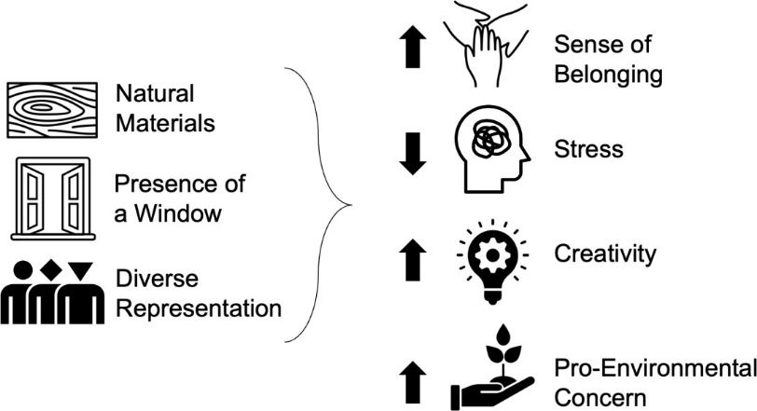
Fig 1: Conceptual diagram highlighting hypothesized relationships between independent
and dependent variables
Source: Agustin, 2022

Table 1: Zoning strategies in coworking spaces and offices of a new type
Source: prykhodko, 2025
Zoning Type | Description | Advantages | Limitations
Open-plan space | A barrier-free area without partitions | High configurability- Facilitates communication | Elevated noise levels- Limited privacy
Semi-open | Areas divided by lightweight movable partitions and screens | Balances interaction & privacy- Enables rapid zone reconfiguration | Requires additional setup time
Enclosed pods | Enclosed booths or phone booths for one to two persons | Provides maximal acoustic and visual privacy- Allows microclimate control | Restricted mobility- High installation cost.

Table 2: Elements of biophilic design and their impact on users
Source: prykhodko,2025
Element | Description | Psychophysiological Effect
Live plants | Green walls; potted plant arrangements | Reduction in cortisol levels; enhancement of concentration (−15 %)
Natural daylighting | Panoramic windows; skylights | Mood enhancement; decrease in fatigue
Water features | Compact fountains; aquariums | Activation of the parasympathetic nervous system; relaxation
View of nature or landscape | Window openings overlooking green areas or water | Stress reduction; cognitive restoration

Conclusions
Please revisit what the research did, re-citing the objectives and if they have been achieved. Produce a list of conclusions derived based on the findings and data.

Discuss the strengths and weaknesses of the research.

Acknowledgements
Please acknowledge any support you received such as grants or help
Ethical Issues
Please acknowledge that the research was conducted following ethical principles

Conflict of Interest
Please declare if there is any conflict of interest related to this project.

Availability of Data
Say of the data generated through this research is available for scrutiny and can be provided upon request.

References must be listed as the following samples.
Arshard, W. N. R. M. & Hassan, K. A. K. (2025) Spatial Experiences and Housing Satisfaction of Living in Old Public Housing Projects: Insights from Georgetown, Malaysia, Archi-Texts e-journal 2(1), 1-10
Audretsch, D. B. & Thurik, A. R. (2001) What’s new about the new economy? Sources of growth in the managed and entrepreneurial economies. Industrial and Corporate Change, 10(1), 267–315.
Agustin, S. (2022) Place Advantage: Applied Psychology for Interior Architecture. Hoboken: John Wiley & Sons.
Bianchi, E., Altaf, B., Tavakoli, A., Douglas, I.P., Landay, J.A. & Billington, S.L. (2022) ‘Human wellbeing responses to real and simulated workplaces: A comparison of in-person, online, and virtual environments: poster abstract’, in Proceedings of the 9th ACM International Conference on Systems for Energy-Efficient Buildings, Cities, and Transportation. New York: Association for Computing Machinery, pp. 299–300.
Csikszentmihalyi, M. (1996) Creativity: Flow and the Psychology of Discovery and Invention. New York: HarperCollins.
Dietrich, A. (2004) The cognitive neuroscience of creativity. Psychonomic Bulletin & Review, 11(6),1011–1026.
De Bono, E. (1993) Serious Creativity: Using the Power of Lateral Thinking to Create New Ideas. New York: Harper Business.
Robson, C. & McCartan, K. (2016) Real World Research: a resource for users of social research methods in applied settings (4th ed.). Wiley.
El Messeidy, R.A.H. (2019) ‘Architecture and city branding: Role of iconic buildings’, Engineering Research Journal, 163 (September)
Grimaldi, R. and Grandi, A. (2005) ‘Business incubators and new venture creation: An assessment of incubating models’, Technovation, 25(2), pp. 111–121.
Liedtka, J. (2017) Evaluating the impact of design thinking in action. Academy of Management Annual Meeting Proceedings, 2017(1), 1–6. https://doi.org/10.5465/AMBPP.2017.177
Manzini, E. (2014) Making things happen: Social innovation and design. Design Issues, 30(1), 57–66. https://doi.org/10.1162/DESI_a_00248
Manzini, E. (2015) Design, When Everybody Designs.
Prykhodko, O. (2025) ‘Features of interior design for coworking spaces and offices of a new type’, The American Journal of Engineering and Technology, 7(9). pp. 2-5 Available at: https://theamericanjournals.com/index.php/tajet/article/view/6896 (Accessed: 8 March 2026).
Robinson, K. (2001) Out of Our Minds: Learning to be Creative. Oxford: Capstone.
Sternberg, R. J. (2001) Handbook of Creativity. Cambridge: Cambridge University Press.
Singhal, A. (2026) Design of Staircase Wells for Residential Settings to Bring about Quality of Space and Spatial Experiences: Insights from a Survey of Villas Designed by Interior designers and Architects., Archi-Texts e-journal 1(1) 89-99
Schumpeter, J. A. (1939) Business Cycles: A Theoretical, Historical, and Statistical Analysis of the Capitalist Process, McGraw-Hill Book Company Inc., New York
Croitoru, A. (2012) ‘A review to a book that is 100 years old’, Journal of Comparative Research in Anthropology and Sociology, 3(2), Winter, pp.146
Economic Development Board of Bahrain (2008) Bahrain Economic Vision 2030. Manama: Economic Development Board.

